Candle Doubts

Friday, September 4, 2020

9:31 AM

Please find my analysis and correct me if wrong.

* + Can we consider all below candles under hammers & inverted hammers

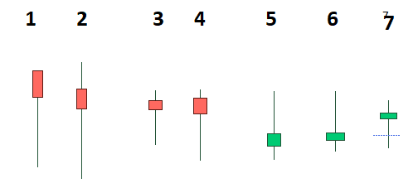

* + All candles shown below can be considered as normal one.

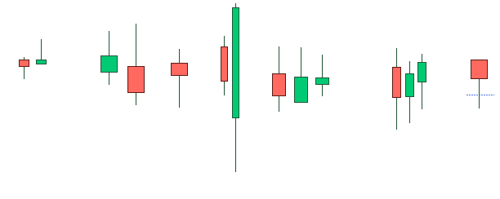

* + Below candles are normal or any specific type?

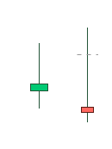

* + Spinning Top: -Can we consider the below candles as spinning Top

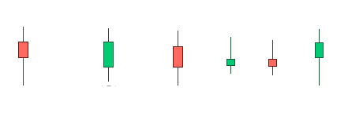

* + One Doji & One Spinning Top & One Inverted Hammer

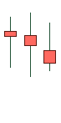

* + Long legged doji

Machine generated alternative text: 

* + Doji

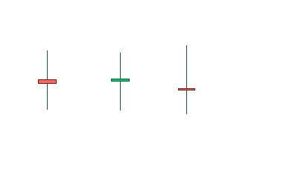

* + High wave

